Addis Ababa University
Science Faculty
Department OF MATHEMATICS
Math 231: Applied Mathematics I
Mid-Semester Examination

Date: December 25,2005
Time: 2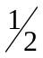 hrs.

Name: _____________________________ I.D. No. _________________
Department: _________________________

Instructions: This examination has two parts, Part I and Part II.

Part I has 15 short answer questions worth two points each to be answered in the blank spaces following each question.

Part II, worth a total of 20 points, has four workout problems; each problem allotted the points shown against it. Show all necessary steps and write clearly in the spaces provided for each problem.

Make sure that your examination paper has six pages.

For Instructor’s Use only

Part I | Part II |  |  |  | Total
Part I | 1 | 2 | 3 | 4

Part I: Short Answer questions

- If u = (1, 2, 3) and v = (4, 5, 6) then
a) U + V = ___________ b) U – V = _____________
- The unit vector in the direction of
V = (-2, 1, 2) is ________________________
- The cosine of the angle between u = i + 2j + 2k and
v = -2i + j + 2k is ______________________
- If u = (0, 5, 6) and v = (1, 2, 3) then proj = ___________________
- If u = (x, -3, 1) is orthogonal to v = (1, x, 2) then x = _______________
- If u and v are any two parallel vectors in R³ then u × v = ____________
- The area of the parallelogram having u = (2, -3, 4) and v = (3, 1,2) as its adjacent sides is ________________________
- The distance of the point P(4, 2, 3) from the plane
π: 2x + 2y – z = 3 is __________________________
- The distance of the point P(1, 2, 3) from the line
L : (0, 2, 1) + t(1, 2, 2), t ∈R is _____________________________
- The coordinates of v = (4, 3) relative to the basis {(2, 1), (-1, 0)}
are ______________________________________
- If A and B are matrices such that det A = 8, det B = 4 and the product A^{t}B⁻¹ is defined then det (A^{t}B⁻¹) = _____________________________
- If A = 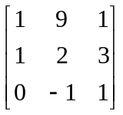 then rank A = __________________________
- If A = 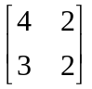 then A⁻¹ = ______________________________
- If A = 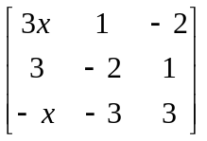 then A is not invertible if
x = __________________
- If A = 2I₃, B = 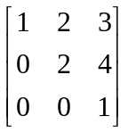 and C = 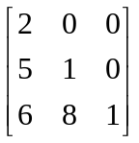 then
det (ABC) = _________________________

Part II: Workout Problems
1. a) Find the distance between π₁: 2x – 2y –z = 4 and
π₂: -6x + 6y + 3z = 0 (3 pts)
b) Find the point of intersection of the line L whose parametric equations are: x = 1-2t, y = 3 + t and z = 5 + t, t ∈R, with the plane π: 2x + 3y – z – 1 = 0.
(3 pts)

2. a) If V = {f\f: R → R and f(x) ≤ 0 ∀x ∈R} show that V is not a vector space.
(3 pts)
b) If V = R² and W = {(x, y) ∈V\ x + y = 0} show that W is a subspace of V.
(3 pts)

- Solve the following system of linear equations using Gaussian elimination method.
x + 2y – z = 6
2x – y + 4z = 2
4x + 3y – 2z = 14
(3 pts)

4. Solve the following system of linear equations using the method of matrix algebra
2x₁ + x₂ – 3x₃ = 1
3x₁ – x₂ – 4x₃ = 7
5x₁ + 2x₂ – 6x₃ = 5
(5 pts)

